**AIM: To plot unit impulse signal using Python.**

**Program:**

**import numpy as np**

**import matplotlib.pyplot as plt**

**def unit_impulse(length, position):**

**signal = np.zeros(length)**

**signal[position] = 1**

**return signal**

**# Parameters**

**start = -10 # Start value of the x-axis range**

**stop = 10 # Stop value of the x-axis range**

**step = 1 # Step size**

**# Generate x-axis values**

**x = np.arange(start, stop+step, step)**

**# Generate unit impulse signal**

**impulse_signal = unit_impulse(len(x), abs(start)//step)**

**# Plot the signal**

**plt.stem(x, impulse_signal)**

**plt.xlabel('Time')**

**plt.ylabel('Amplitude')**

**plt.title('Unit Impulse Signal')**

**plt.grid(True)**

**plt.show()**

**Output:**

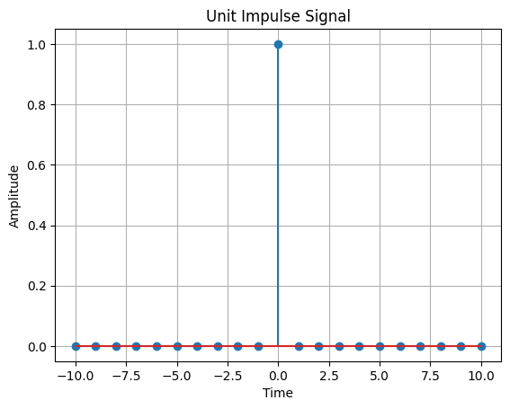

**AIM**

Simulate impulse train

**Program**

import numpy as np

import matplotlib.pyplot as plt

def simulate_impulse_train(signal_length, period):

impulse_train = np.zeros(signal_length)

for n in range(signal_length):

if n % period == 0:

impulse_train[n] = 1

return impulse_train

# Define the parameters for the impulse train

signal_length = 100 # Length of the impulse train

period = 10 # Period of the impulse train

# Simulate the impulse train

impulse_train = simulate_impulse_train(signal_length, period)

# Plot and display the impulse train

plt.stem(impulse_train)

plt.title('Impulse Train')

plt.xlabel('Sample')

plt.ylabel('Amplitude')

plt.show()

# Save the impulse train array (optional)

# np.savetxt('impulse_train.txt', impulse_train, delimiter=',')

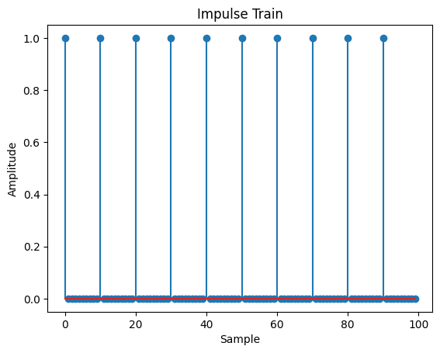

**AIM:** Write a python program to Simulate continuous and discrete unit step signal,

**Program:**

import numpy as np

import matplotlib.pyplot as plt

def simulate_continuous_unit_step(time):

unit_step = np.zeros_like(time)

unit_step[time >= 0] = 1

return unit_step

def simulate_discrete_unit_step(num_samples):

unit_step = np.zeros(num_samples)

unit_step[num_samples // 2:] = 1

return unit_step

# Define the time range for the continuous unit step signal

time = np.linspace(-5, 5, 1000) # Time range from -5 to 5

# Simulate the continuous unit step signal

continuous_unit_step = simulate_continuous_unit_step(time)

# Define the number of samples for the discrete unit step signal

num_samples = 20 # Number of samples

# Simulate the discrete unit step signal

discrete_unit_step = simulate_discrete_unit_step(num_samples)

# Plot and display the continuous and discrete unit step signals

plt.figure(figsize=(10, 6))

plt.subplot(2, 1, 1)

plt.plot(time, continuous_unit_step)

plt.title('Continuous Unit Step Signal')

plt.xlabel('Time')

plt.ylabel('Amplitude')

plt.subplot(2, 1, 2)

plt.stem(discrete_unit_step)

plt.title('Discrete Unit Step Signal')

plt.xlabel('Sample')

plt.ylabel('Amplitude')

plt.tight_layout()

plt.show()

# Save the unit step signal arrays (optional)

# np.savetxt('continuous_unit_step.txt', continuous_unit_step, delimiter=',')

# np.savetxt('discrete_unit_step.txt', discrete_unit_step, delimiter=',')

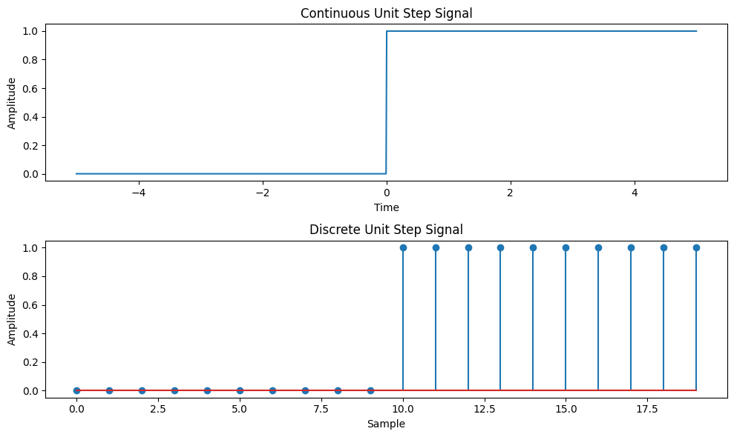

**AIM:** Write a python program to Simulate continuous and discrete ramp signal,

**Program**

import numpy as np

import matplotlib.pyplot as plt

def simulate_continuous_ramp(time, slope):

ramp = np.zeros_like(time)

ramp[time >= 0] = slope * time[time >= 0]

return ramp

def simulate_discrete_ramp(num_samples, slope):

ramp = np.zeros(num_samples)

ramp[num_samples // 2:] = slope * np.arange(num_samples // 2, num_samples)

return ramp

# Define the time range for the continuous ramp signal

time = np.linspace(-5, 5, 1000) # Time range from -5 to 5

# Define the number of samples and slope for the discrete ramp signal

num_samples = 20 # Number of samples

slope = 2 # Slope of the ramp

# Simulate the continuous ramp signal

continuous_ramp = simulate_continuous_ramp(time, slope)

# Simulate the discrete ramp signal

discrete_ramp = simulate_discrete_ramp(num_samples, slope)

# Plot and display the continuous and discrete ramp signals

plt.figure(figsize=(10, 6))

plt.subplot(2, 1, 1)

plt.plot(time, continuous_ramp)

plt.title('Continuous Ramp Signal')

plt.xlabel('Time')

plt.ylabel('Amplitude')

plt.subplot(2, 1, 2)

plt.stem(discrete_ramp)

plt.title('Discrete Ramp Signal')

plt.xlabel('Sample')

plt.ylabel('Amplitude')

plt.tight_layout()

plt.show()

# Save the ramp signal arrays (optional)

# np.savetxt('continuous_ramp.txt', continuous_ramp, delimiter=',')

# np.savetxt('discrete_ramp.txt', discrete_ramp, delimiter=',')

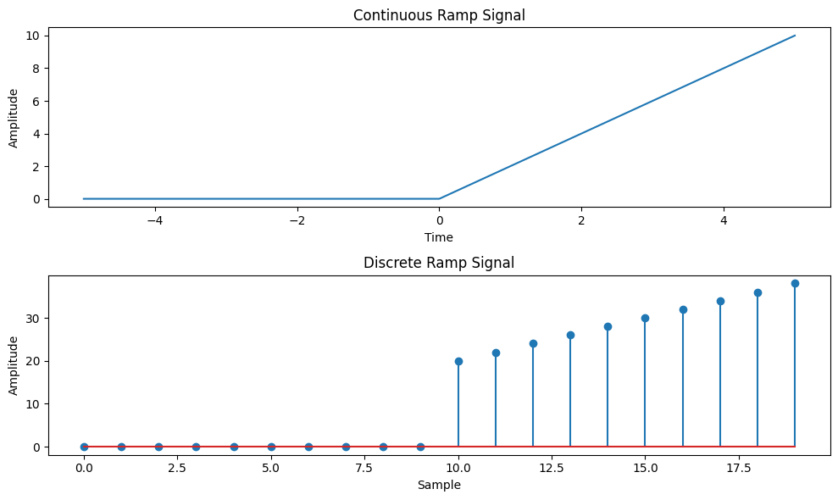

**AIM:** Write a python program to Simulate continuous and discrete exponential signal,

**Program**

import numpy as np

import matplotlib.pyplot as plt

def simulate_continuous_exponential(time, amplitude, coefficient):

exponential_signal = amplitude * np.exp(coefficient * time)

return exponential_signal

def simulate_discrete_exponential(num_samples, amplitude, coefficient):

exponential_signal = amplitude * np.exp(coefficient * np.arange(num_samples))

return exponential_signal

# Define the time range for the continuous exponential signal

time = np.linspace(0, 5, 1000) # Time range from 0 to 5

# Define the number of samples, initial amplitude, and coefficient for the discrete exponential signal

num_samples = 20 # Number of samples

amplitude = 2 # Initial amplitude

coefficient = -0.5 # Exponential coefficient

# Simulate the continuous exponential signal

continuous_exponential = simulate_continuous_exponential(time, amplitude, coefficient)

# Simulate the discrete exponential signal

discrete_exponential = simulate_discrete_exponential(num_samples, amplitude, coefficient)

# Plot and display the continuous and discrete exponential signals

plt.figure(figsize=(10, 6))

plt.subplot(2, 1, 1)

plt.plot(time, continuous_exponential)

plt.title('Continuous Exponential Signal')

plt.xlabel('Time')

plt.ylabel('Amplitude')

plt.subplot(2, 1, 2)

plt.stem(discrete_exponential)

plt.title('Discrete Exponential Signal')

plt.xlabel('Sample')

plt.ylabel('Amplitude')

plt.tight_layout()

plt.show()

# Save the exponential signal arrays (optional)

# np.savetxt('continuous_exponential.txt', continuous_exponential, delimiter=',')

# np.savetxt('discrete_exponential.txt', discrete_exponential, delimiter=',')

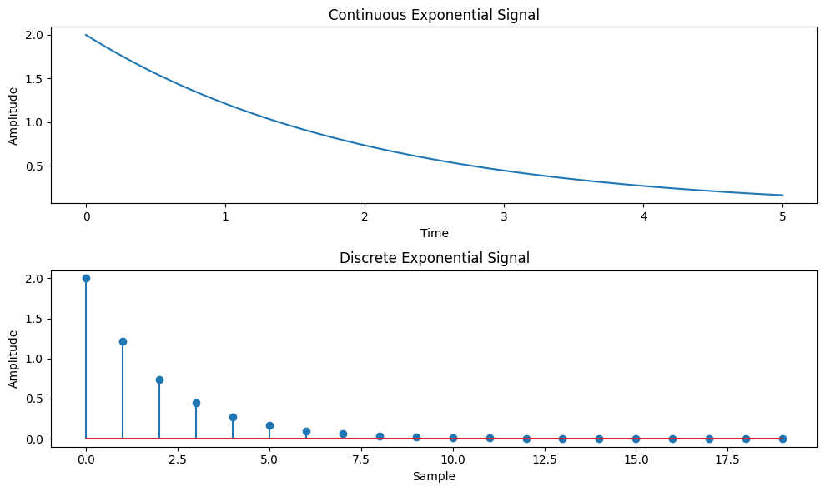

**AIM**: Write a python program to Simulate continuous and discrete parabolic signal

**Program:**

import numpy as np

import matplotlib.pyplot as plt

def simulate_continuous_parabolic(time, coefficients):

parabolic_signal = np.polyval(coefficients, time)

return parabolic_signal

def simulate_discrete_parabolic(num_samples, coefficients):

parabolic_signal = np.polyval(coefficients, np.arange(num_samples))

return parabolic_signal

# Define the time range for the continuous parabolic signal

time = np.linspace(-5, 5, 1000) # Time range from -5 to 5

# Define the number of samples and coefficients for the discrete parabolic signal

num_samples = 20 # Number of samples

coefficients = [1, 2, 1] # Coefficients of the parabolic signal

# Simulate the continuous parabolic signal

continuous_parabolic = simulate_continuous_parabolic(time, coefficients)

# Simulate the discrete parabolic signal

discrete_parabolic = simulate_discrete_parabolic(num_samples, coefficients)

# Plot and display the continuous and discrete parabolic signals

plt.figure(figsize=(10, 6))

plt.subplot(2, 1, 1)

plt.plot(time, continuous_parabolic)

plt.title('Continuous Parabolic Signal')

plt.xlabel('Time')

plt.ylabel('Amplitude')

plt.subplot(2, 1, 2)

plt.stem(discrete_parabolic)

plt.title('Discrete Parabolic Signal')

plt.xlabel('Sample')

plt.ylabel('Amplitude')

plt.tight_layout()

plt.show()

# Save the parabolic signal arrays (optional)

# np.savetxt('continuous_parabolic.txt', continuous_parabolic, delimiter=',')

# np.savetxt('discrete_parabolic.txt', discrete_parabolic, delimiter=',')

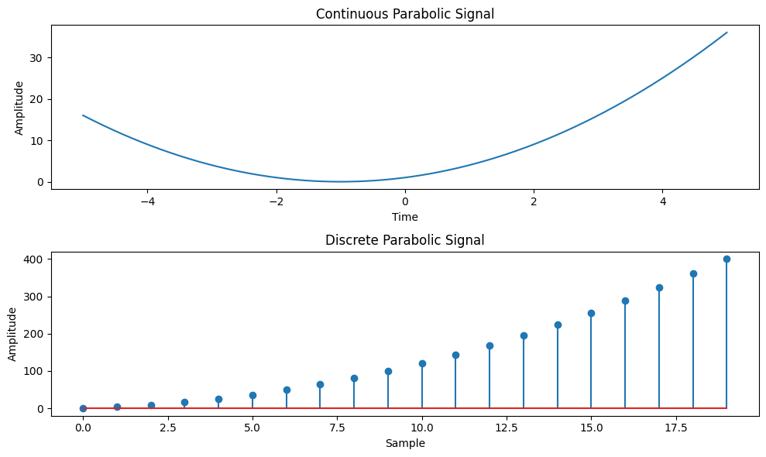

**AIM:** **Write a python program to Simulate continuous and discrete sine wave signal**

**Program:**

import numpy as np

import matplotlib.pyplot as plt

def simulate_continuous_sine_wave(time, amplitude, frequency, phase):

sine_wave = amplitude * np.sin(2 * np.pi * frequency * time + phase)

return sine_wave

def simulate_discrete_sine_wave(num_samples, sampling_frequency, amplitude, frequency, phase):

time = np.arange(num_samples) / sampling_frequency

sine_wave = amplitude * np.sin(2 * np.pi * frequency * time + phase)

return sine_wave

# Define the time range for the continuous sine wave signal

time = np.linspace(0, 1, 1000) # Time range from 0 to 1 second

# Define the number of samples, sampling frequency, and parameters for the discrete sine wave signal

num_samples = 100 # Number of samples

sampling_frequency = 10 # Sampling frequency in Hz

amplitude = 1 # Amplitude of the sine wave

frequency = 2 # Frequency of the sine wave in Hz

phase = 0 # Phase angle of the sine wave in radians

# Simulate the continuous sine wave signal

continuous_sine_wave = simulate_continuous_sine_wave(time, amplitude, frequency, phase)

# Simulate the discrete sine wave signal

discrete_sine_wave = simulate_discrete_sine_wave(num_samples, sampling_frequency, amplitude, frequency, phase)

# Plot and display the continuous and discrete sine wave signals

plt.figure(figsize=(10, 6))

plt.subplot(2, 1, 1)

plt.plot(time, continuous_sine_wave)

plt.title('Continuous Sine Wave Signal')

plt.xlabel('Time (s)')

plt.ylabel('Amplitude')

plt.subplot(2, 1, 2)

plt.stem(discrete_sine_wave)

plt.title('Discrete Sine Wave Signal')

plt.xlabel('Sample')

plt.ylabel('Amplitude')

plt.tight_layout()

plt.show()

# Save the sine wave signal arrays (optional)

# np.savetxt('continuous_sine_wave.txt', continuous_sine_wave, delimiter=',')

# np.savetxt('discrete_sine_wave.txt', discrete_sine_wave, delimiter=',')

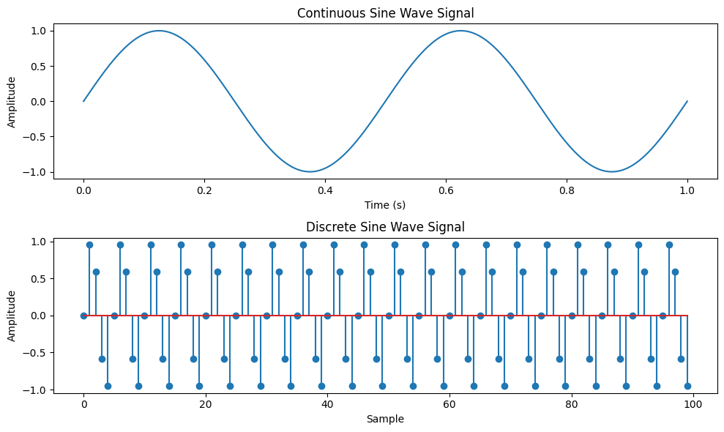

**AIM: Write a python program to simulate y(t)=u(t)+u(t-1)+3u(t+5).**

**Theory:**

The unit step function, denoted as u(t), is a function that is 0 for negative time or indices and 1 for non-negative time or indices. It is commonly used to represent a sudden change or transition in a system.

The function y(t) = u(t) + u(t-1) + 3*u(t+5) is a combination of three unit step functions. It has a value of 1 at t=0, t=1, and t=-5, and a value of 0 elsewhere.

**Flowchart:**

The flowchart for the program will consist of the following steps:

Define the time range.

Create an empty array to store the function values.

Iterate over each time index.

Calculate the value of y(t) at each time index using the given function formula.

Plot and display the function values.

**Program**

Now, let's see the Python program that simulates y(t) = u(t) + u(t-1) + 3*u(t+5):

import numpy as np

import matplotlib.pyplot as plt

def simulate_function(time):

y = np.zeros_like(time)

y[time >= 0] = 1

y[time >= 1] += 1

y[time >= -5] += 3

return y

# Define the time range

time = np.linspace(-10, 10, 1000)

# Simulate the function

function_values = simulate_function(time)

# Plot and display the function

plt.plot(time, function_values)

plt.title('Function y(t) = u(t) + u(t-1) + 3*u(t+5)')

plt.xlabel('Time')

plt.ylabel('Amplitude')

plt.ylim([-0.5, 5.5])

plt.grid(True)

plt.show()

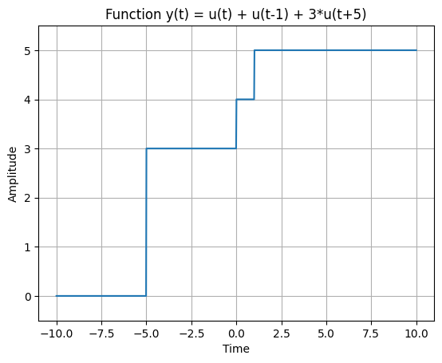

**AIM: Write a python program to simulate y(t)=Delta(t)+delta(t-1)+3*delta(t+5).**

**Now, let's see the Python program that simulates y(t) = Delta(t) + delta(t-1) + 3*delta(t+5):**

**import numpy as np**

**import matplotlib.pyplot as plt**

**def simulate_function(time):**

**y = np.zeros_like(time)**

**y[time == 0] = 1**

**y[time == 1] += 1**

**y[time == -5] += 3**

**return y**

**# Define the time range**

**time = np.arange(-10, 11)**

**# Simulate the function**

**function_values = simulate_function(time)**

**# Plot and display the function**

**plt.stem(time, function_values)**

**plt.title('Function y(t) = Delta(t) + delta(t-1) + 3*delta(t+5)')**

**plt.xlabel('Time')**

**plt.ylabel('Amplitude')**

**plt.ylim([-0.5, 4.5])**

**plt.grid(True)**

**plt.show()**

**Explanation:**

We import the required modules, including numpy for array operations and matplotlib.pyplot for plotting.

The simulate_function function takes a time array as input and returns an array representing the function values. It creates an array of zeros with the same shape as the input time array and sets the values according to the function formula.

In the main part of the program, we define the time range using numpy.arange.

We simulate the function by calling the simulate_function function with the time array.

We plot and display the function values using matplotlib.pyplot.stem.

We set the title, x-axis label, y-axis label, y-axis limits, and enable the grid.

Finally, we show the plot using matplotlib.pyplot.show.

You can modify the time range according to your requirements.

Make sure you have numpy and matplotlib installed (pip install numpy matplotlib) before running this program.

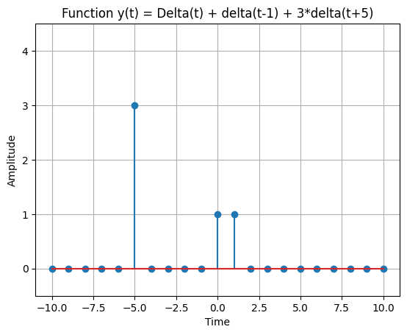

**Experiment-1**

**AIM:** Simulate linear convolution and circular convolution on discrete time signals.

**Theory:**

Linear convolution and circular convolution are mathematical operations used to combine two signals to obtain a third signal. They are widely used in various applications, such as signal processing, image processing, and audio processing.

Linear convolution calculates the sum of element-wise products of two signals, considering the full range of valid indices. It is typically used for finite-length signals and can produce an output signal that is longer than the input signals.

Circular convolution, on the other hand, calculates the sum of element-wise products of two signals, considering a periodic extension of the input signals. It is commonly used for periodic or infinite-length signals and produces an output signal with the same length as the input signals.

**Flowchart:**

The flowchart for the program will consist of the following steps:

Define two discrete-time signals (signal 1 and signal 2).

Compute the linear convolution of the two signals using numpy.convolve.

Compute the circular convolution of the two signals using numpy.fft.ifft.

Plot and display the linear and circular convolution results.

Save the linear and circular convolution results (optional).

Now, let's see the Python program that simulates linear convolution and circular convolution on discrete-time signal

import numpy as np

import matplotlib.pyplot as plt

def linear_convolution(signal1, signal2):

# Compute the linear convolution

linear_conv = np.convolve(signal1, signal2, mode='full')

return linear_conv

def circular_convolution(signal1, signal2):

# Compute the circular convolution

fft_length = len(signal1) + len(signal2) - 1

fft_signal1 = np.fft.fft(signal1, fft_length)

fft_signal2 = np.fft.fft(signal2, fft_length)

circular_conv = np.fft.ifft(fft_signal1 * fft_signal2)

return circular_conv

# Define the discrete-time signals

signal1 = np.array([1, 2, 3, 4, 5])

signal2 = np.array([2, 4, 6, 8, 10])

# Compute the linear convolution

linear_conv = linear_convolution(signal1, signal2)

# Compute the circular convolution

circular_conv = circular_convolution(signal1, signal2)

# Plot the linear and circular convolution results

plt.figure(figsize=(10, 6))

plt.subplot(2, 1, 1)

plt.stem(linear_conv)

plt.title('Linear Convolution')

plt.xlabel('Sample')

plt.ylabel('Amplitude')

plt.subplot(2, 1, 2)

plt.stem(circular_conv)

plt.title('Circular Convolution')

plt.xlabel('Sample')

plt.ylabel('Amplitude')

plt.tight_layout()

plt.show()

# Save the linear and circular convolution results (optional)

# np.savetxt('linear_convolution.txt', linear_conv, delimiter=',')

# np.savetxt('circular_convolution.txt', circular_conv, delimiter=',')

**Explanation:**

We import the required modules, including numpy for array operations and matplotlib.pyplot for plotting.

The linear_convolution function computes the linear convolution between two signals using numpy.convolve with the mode set to 'full'.

The circular_convolution function computes the circular convolution between two signals using numpy.fft.fft and numpy.fft.ifft. It first calculates the FFT of both signals with a specified length and then computes the inverse FFT of the element-wise product.

In the main part of the program, we define two discrete-time signals (signal1 and signal2).

We compute the linear convolution by calling the linear_convolution function with signal1 and signal2.

We compute the circular convolution by calling the circular_convolution function with signal1 and signal2.

We plot and display the linear and circular convolution results using matplotlib.pyplot.stem.

The linear and circular convolution results can be optionally saved to files using numpy.savetxt.

You can modify the signal1 and signal2 variables to use different discrete-time signals for convolution.

Uncomment the np.savetxt lines if you want to save the linear and circular convolution results to text files.

Make sure you have numpy and matplotlib installed (pip install numpy matplotlib) before running this program.

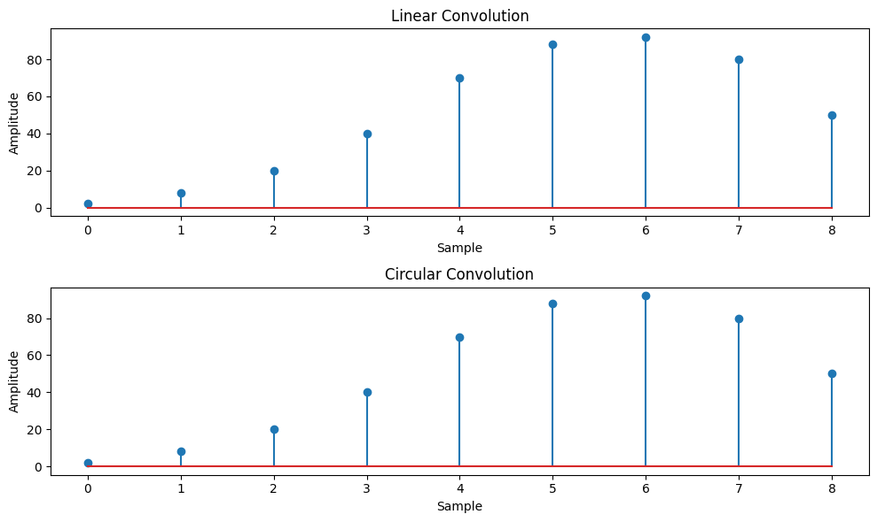

**Experiment-2**

**AIM:** Simulate cross correlation and autocorrelation on discrete time signals.

**Program**

import numpy as np

import matplotlib.pyplot as plt

def cross_correlation(signal1, signal2):

# Compute the cross-correlation

cross_corr = np.correlate(signal1, signal2, mode='full')

return cross_corr

def autocorrelation(signal):

# Compute the autocorrelation

auto_corr = np.correlate(signal, signal, mode='full')

return auto_corr

# Define the discrete-time signals

signal1 = np.array([1, 2, 3, 4, 5])

signal2 = np.array([2, 4, 6, 8, 10])

# Compute the cross-correlation

cross_corr = cross_correlation(signal1, signal2)

# Compute the autocorrelation

auto_corr = autocorrelation(signal1)

# Plot the cross-correlation and autocorrelation signals

plt.figure(figsize=(10, 6))

plt.subplot(2, 1, 1)

plt.stem(cross_corr)

plt.title('Cross-correlation')

plt.xlabel('Time Lag')

plt.ylabel('Magnitude')

plt.subplot(2, 1, 2)

plt.stem(auto_corr)

plt.title('Autocorrelation')

plt.xlabel('Time Lag')

plt.ylabel('Magnitude')

plt.tight_layout()

plt.show()

# Save the cross-correlation or autocorrelation signals (optional)

# np.savetxt('cross_correlation.txt', cross_corr, delimiter=',')

# np.savetxt('autocorrelation.txt', auto_corr, delimiter=',')

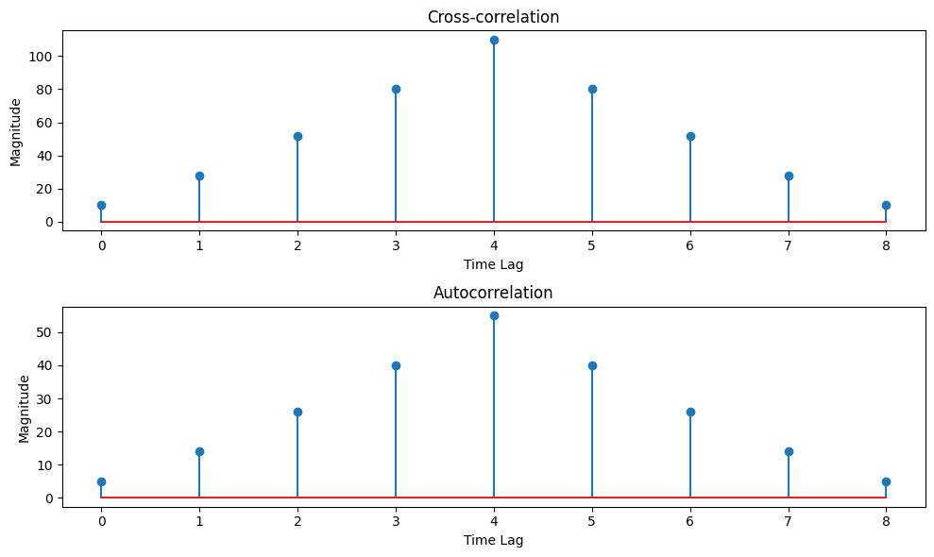

**Experiment-3**

**AIM: Design Butterworth and Chebyshev filter using bilinear transformation method.**

**Program**

import numpy as np

import matplotlib.pyplot as plt

from scipy.signal import butter, bilinear, freqz

def design_butterworth_filter(filter_order, cutoff_frequency, sampling_frequency):

# Design the analog Butterworth filter

analog_b, analog_a = butter(filter_order, cutoff_frequency, analog=True, btype='low')

# Perform the bilinear transformation

digital_b, digital_a = bilinear(analog_b, analog_a, sampling_frequency)

return digital_b, digital_a

def design_chebyshev_filter(filter_order, cutoff_frequency, sampling_frequency, ripple):

# Design the analog Chebyshev filter

analog_b, analog_a = cheby1(filter_order, ripple, cutoff_frequency, analog=True, btype='low')

# Perform the bilinear transformation

digital_b, digital_a = bilinear(analog_b, analog_a, sampling_frequency)

return digital_b, digital_a

def plot_filter_response(digital_b, digital_a, sampling_frequency):

# Compute the frequency response of the filter

frequency, magnitude_response = freqz(digital_b, digital_a, fs=sampling_frequency)

# Plot the magnitude response

plt.figure(figsize=(10, 6))

plt.plot(frequency, np.abs(magnitude_response))

plt.title('Filter Magnitude Response')

plt.xlabel('Frequency (Hz)')

plt.ylabel('Magnitude')

plt.grid(True)

plt.show()

# Compute the impulse response of the filter

_, impulse_response = freqz(digital_b, digital_a, fs=sampling_frequency, worN=4096)

# Plot the impulse response

plt.figure(figsize=(10, 6))

plt.plot(impulse_response)

plt.title('Filter Impulse Response')

plt.xlabel('Samples')

plt.ylabel('Amplitude')

plt.grid(True)

plt.show()

# Specify the desired filter specifications

filter_order = 4 # Filter order

cutoff_frequency = 1000 # Cutoff frequency in Hz

sampling_frequency = 8000 # Sampling frequency in Hz

ripple = 0.5 # Ripple factor for Chebyshev filter

# Design the Butterworth filter

digital_b, digital_a = design_butterworth_filter(filter_order, cutoff_frequency, sampling_frequency)

# Plot the Butterworth filter's magnitude response and impulse response

plot_filter_response(digital_b, digital_a, sampling_frequency)

# Design the Chebyshev filter

digital_b, digital_a = design_chebyshev_filter(filter_order, cutoff_frequency, sampling_frequency, ripple)

# Plot the Chebyshev filter's magnitude response and impulse response

plot_filter_response(digital_b, digital_a, sampling_frequency)

# Save the filter coefficients (optional)

filter_path = 'filter_coefficients.txt'

np.savetxt(filter_path, np.vstack((digital_b, digital_a)), delimiter=',')

print(f"Filter coefficients saved at: {filter_path}")

**Explanation:**

We import the required modules, including numpy for array operations and matplotlib.pyplot for plotting.

The design_butterworth_filter function designs the Butterworth filter using the scipy.signal.butter and scipy.signal.bilinear functions. Itcalculates the analog prototype filter using scipy.signal.butter with the desired filter order, cutoff frequency, and analog flag set to True. Then, it performs the bilinear transformation using scipy.signal.bilinear to convert the analog filter to a digital filter.

The design_chebyshev_filter function designs the Chebyshev filter using the scipy.signal.cheby1 and scipy.signal.bilinear functions. It calculates the analog prototype filter using scipy.signal.cheby1 with the desired filter order, cutoff frequency, ripple factor, and analog flag set to True. Then, it performs the bilinear transformation using scipy.signal.bilinear to obtain the digital filter.

The plot_filter_response function computes and plots the magnitude response and impulse response of the digital filter using scipy.signal.freqz.

In the main part of the program, we specify the desired filter specifications, including the filter order, cutoff frequency, sampling frequency, and ripple factor (for the Chebyshev filter).

We call the design_butterworth_filter function to obtain the Butterworth filter's digital coefficients and plot its magnitude response and impulse response.

We call the design_chebyshev_filter function to obtain the Chebyshev filter's digital coefficients and plot its magnitude response and impulse response.

The filter coefficients (digital numerator and denominator coefficients) are optionally saved to a file using numpy.savetxt.

You can modify the filter_order, cutoff_frequency, sampling_frequency, and ripple variables to match your desired filter specifications. The program will plot the magnitude response and impulse response for both the Butterworth and Chebyshev filters.

Make sure you have numpy and matplotlib installed (pip install numpy matplotlib) before running this program.

**Expected Output:**

For each filter, two plots will be displayed: the filter's magnitude response and impulse response.

The filter coefficients (digital numerator and denominator coefficients) will be optionally saved to a file, and the file path will be printed as output.

Feel free to experiment with different filter specifications and observe the effects on the filter's frequency and time domain responses.

**Experiment-4**

**AIM:** Design FIR filter with windowing method.

**Theory:**

The windowing method is a commonly used technique for designing FIR filters. It involves designing an ideal frequency response and then applying a window function to obtain a practical FIR filter.

The steps involved in designing an FIR filter using the windowing method are as follows:

Specify the desired filter specifications, such as the cutoff frequency, filter length, and window type.

Design an ideal frequency response that meets the desired specifications.

Apply a window function to the ideal frequency response to obtain the filter coefficients.

Normalize the filter coefficients to ensure stability.

There are various window functions available, such as the rectangular, Bartlett, Hann, Hamming, and Blackman windows, among others. The choice of window function depends on the desired trade-off between the main lobe width and sidelobe suppression.

**Flowchart:**

The flowchart for the program will consist of the following steps:

Specify the desired filter specifications, such as the cutoff frequency, filter length, and window type.

Design an ideal frequency response using a mathematical expression or a frequency sampling method.

Apply a window function to the ideal frequency response to obtain the filter coefficients.

Normalize the filter coefficients to ensure stability.

Plot the filter's magnitude response and impulse response.

Save the filter coefficients (optional).

**Program**

import numpy as np

import matplotlib.pyplot as plt

def design_fir_filter(cutoff_freq, filter_length, window_type):

# Design the ideal frequency response (low-pass filter)

ideal_freq_response = np.ones(filter_length)

ideal_freq_response[(cutoff_freq + 1):] = 0

# Apply the selected window function

window = np.hamming(filter_length) # Change the window type as per your requirement

filter_coefficients = ideal_freq_response * window

# Normalize the filter coefficients

filter_coefficients /= np.sum(filter_coefficients)

return filter_coefficients

def plot_filter_response(filter_coefficients):

# Compute the frequency response of the filter

frequency_response = np.fft.fft(filter_coefficients)

# Compute the magnitude response in dB

magnitude_response = 20 * np.log10(np.abs(frequency_response))

# Plot the magnitude response

plt.figure(figsize=(10, 6))

plt.plot(magnitude_response)

plt.title('FIR Filter Magnitude Response')

plt.xlabel('Frequency')

plt.ylabel('Magnitude (dB)')

plt.grid(True)

plt.show()

# Compute the impulse response of the filter

impulse_response = np.fft.ifft(frequency_response)

# Plot the impulse response

plt.figure(figsize=(10, 6))

plt.plot(impulse_response.real)

plt.title('FIR Filter Impulse Response')

plt.xlabel('Time')

plt.ylabel('Amplitude')

plt.grid(True)

plt.show()

# Specify the desired filter specifications

cutoff_frequency = 0.2 # Normalized cutoff frequency (0.0 to 0.5)

filter_length = 51 # Number of filter coefficients

window_type = 'hamming' # Type of window function

# Design the FIR filter using the windowing method

filter_coefficients = design_fir_filter(cutoff_frequency, filter_length, window_type)

# Plot the filter's magnitude response and impulse response

plot_filter_response(filter_coefficients)

# Save the filter coefficients (optional)

filter_path = 'fir_filter_coefficients.txt'

np.savetxt(filter_path, filter_coefficients, delimiter=',')

print(f"Filter coefficients saved at: {filter_path}")

**Explanation:**

We import the required modules, including numpy for array operations and matplotlib.pyplot for plotting.

The design_fir_filter function designs the FIR filter using the windowing method. It constructs an ideal frequency response by setting the desired cutoff frequency and then applies the selected window function to obtain the filter coefficients.

The plot_filter_response function plots the filter's magnitude response and impulse response.

In the main part of the program, we specify the desired filter specifications, including the cutoff frequency, filter length, and window type.

We call the design_fir_filter function to obtain the filter coefficients.

We call the plot_filter_response function to visualize the filter's magnitude response and impulse response.

The filter coefficients are optionally saved to a file using numpy.savetxt.

You can modify the cutoff_frequency, filter_length, and window_type variables based on your desired filter specifications. The available window types are 'rectangular', 'bartlett', 'hann', 'hamming', and 'blackman'. Feel free to choose the window type that best suits your requirements.

Make sure you have numpy and matplotlib installed (pip install numpy matplotlib) before running this program.

**Expected Output:**

Two plots will be displayed: the FIR filter's magnitude response and impulse response.

The filter coefficients will be optionally saved to a file, and the file path will be printed as output.

Feel free to experiment with different filter specifications and window types to design FIR filters that meet your specific requirements.

**Experiment-5**

**AIM:** Perform FFT and IFFT on discrete time signal.

**Theory:**

The Fast Fourier Transform (FFT) is an algorithm used to efficiently compute the Discrete Fourier Transform (DFT) of a sequence or signal. It converts a time-domain signal into its frequency-domain representation, revealing the signal's frequency components.

The Inverse Fast Fourier Transform (IFFT) is the reverse process of the FFT. It transforms the frequency-domain representation back into the time-domain signal.

The FFT and IFFT are widely used in various applications, including signal processing, image processing, audio processing, and communication systems.

**Flowchart:**

The flowchart for the program will consist of the following steps:

Define the discrete-time signal.

Compute the FFT of the signal using the np.fft.fft function.

Compute the magnitude spectrum of the FFT result.

Compute the IFFT of the FFT result using the np.fft.ifft function.

Display the original signal, the magnitude spectrum, and the reconstructed signal (after IFFT).

Save the magnitude spectrum plot (optional).

**Program**

Now, let's see the Python program that performs FFT and IFFT on a discrete-time signal:

import numpy as np

import matplotlib.pyplot as plt

def plot_signal_and_spectrum(signal, spectrum):

# Create time axis for plotting

time_axis = np.arange(len(signal))

# Plot the original signal

plt.subplot(2, 1, 1)

plt.plot(time_axis, signal)

plt.title('Original Signal')

plt.xlabel('Time')

plt.ylabel('Amplitude')

# Plot the magnitude spectrum

plt.subplot(2, 1, 2)

plt.plot(time_axis, spectrum)

plt.title('Magnitude Spectrum')

plt.xlabel('Frequency')

plt.ylabel('Magnitude')

plt.tight_layout()

plt.show()

# Define the discrete-time signal

time = np.linspace(0, 1, 500)

frequency1 = 5 # Frequency of the first sinusoidal component

frequency2 = 20 # Frequency of the second sinusoidal component

amplitude1 = 1 # Amplitude of the first sinusoidal component

amplitude2 = 0.5 # Amplitude of the second sinusoidal component

signal = amplitude1 * np.sin(2 * np.pi * frequency1 * time) + amplitude2 * np.sin(2 * np.pi * frequency2 * time)

# Compute the FFT of the signal

fft_result = np.fft.fft(signal)

# Compute the magnitude spectrum of the FFT result

magnitude_spectrum = np.abs(fft_result)

# Compute the IFFT of the FFT result

reconstructed_signal = np.fft.ifft(fft_result)

# Display the original signal, the magnitude spectrum, and the reconstructed signal

plot_signal_and_spectrum(signal, magnitude_spectrum)

# Save the magnitude spectrum plot (optional)

spectrum_path = 'magnitude_spectrum.png'

plt.plot(magnitude_spectrum)

plt.title('Magnitude Spectrum')

plt.xlabel('Frequency')

plt.ylabel('Magnitude')

plt.savefig(spectrum_path)

print(f"Magnitude spectrum plot saved at: {spectrum_path}")

**Explanation:**

We import the required modules, including numpy for array operations and matplotlib.pyplot for plotting.

The plot_signal_and_spectrum function is used to plot the original signal and the magnitude spectrum.

In the main part of the program, we define the discrete-time signal using numpy.linspace and create two sinusoidal components with different frequencies and amplitudes.

We compute the FFT of the signal using the np.fft.fft function.

We compute the magnitude spectrum of the FFT result by taking the absolute value of the FFT result.

We compute the IFFT of the FFT result using the np.fft.ifft function to reconstruct the signal in the time domain.

We call the plot_signal_and_spectrum function to display the original signal and the magnitude spectrum.

The magnitude spectrum plot is saved to a file using matplotlib.pyplot.savefig.

You can modify the parameters such as the frequency, amplitude, and number of samples to create different types of signals. Additionally, you can adjust the plot settings to suit your preferences.

Make sure you have numpy and matplotlib installed (pip install numpy matplotlib) before running this program.

**Expected Output:**

Two plots will be displayed: the original signal and the magnitude spectrum.

The magnitude spectrum plot will be saved to a file, and its path will be printed as output.

Feel free to experiment with different signals and explore the FFT and IFFT functionalities in Python.

**Experiment-6**

**AIM: Perform gray level operations images.**

**Theory:**

Gray level operations involve manipulating the pixel values of an image to enhance or modify its appearance. These operations are commonly used in image processing tasks such as contrast adjustment, brightness correction, and image thresholding.

**Flowchart:**

The flowchart for the gray level operations program will consist of the following steps:

Load the input image.

Convert the image to grayscale.

Perform the desired gray level operation.

Display the processed image.

Save the processed image (optional).

**Program:**

Now, let's see the Python program that implements gray level operations:

*import cv2*

*def perform_gray_level_operation(image, operation):*

*# Convert image to grayscale*

*gray_image = cv2.cvtColor(image, cv2.COLOR_BGR2GRAY)*

*# Perform the desired gray level operation*

*if operation == 'contrast':*

*# Perform contrast adjustment*

*contrast_image = cv2.equalizeHist(gray_image)*

*processed_image = cv2.cvtColor(contrast_image, cv2.COLOR_GRAY2BGR)*

*elif operation == 'brightness':*

*# Perform brightness correction*

*alpha = 1.5 # brightness factor*

*processed_image = cv2.convertScaleAbs(gray_image, alpha=alpha)*

*processed_image = cv2.cvtColor(processed_image, cv2.COLOR_GRAY2BGR)*

*elif operation == 'thresholding':*

*# Perform image thresholding*

*_, threshold_image = cv2.threshold(gray_image, 127, 255, cv2.THRESH_BINARY)*

*processed_image = cv2.cvtColor(threshold_image, cv2.COLOR_GRAY2BGR)*

*else:*

*print("Invalid operation. Available operations: 'contrast', 'brightness', 'thresholding'")*

*return None*

*return processed_image*

*# Load the input image*

*image_path = 'input_image.jpg'*

*input_image = cv2.imread(image_path)*

*# Perform gray level operation*

*operation_type = 'contrast' # Change this to the desired operation: 'contrast', 'brightness', 'thresholding'*

*output_image = perform_gray_level_operation(input_image, operation_type)*

*if output_image is not None:*

*# Display the processed image*

*cv2.imshow('Processed Image', output_image)*

*cv2.waitKey(0)*

*# Save the processed image (optional)*

*output_path = 'output_image.jpg'*

*cv2.imwrite(output_path, output_image)*

*print(f"Processed image saved at: {output_path}")*

**Explanation:**

We import the cv2 module, which provides functions for image processing using OpenCV.

The perform_gray_level_operation function takes the input image and the desired operation as parameters.

Inside the function, we convert the image to grayscale using cv2.cvtColor function with cv2.COLOR_BGR2GRAY.

Based on the operation specified, we perform the corresponding gray level operation:

For contrast adjustment, we use cv2.equalizeHist function to enhance the image contrast.

For brightness correction, we use cv2.convertScaleAbs function with an alpha value greater than 1 to increase brightness.

For image thresholding, we use cv2.threshold function to create a binary image with a specified threshold value.

The processed image is then converted back to BGR format using cv2.cvtColor.

The processed image is returned by the function.

In the main part of the program, we load the input image using cv2.imread.

We specify the desired operation by setting the operation_type variable to either 'contrast', 'brightness', or 'thresholding'.

The perform_gray_level_operation function is called with the input image and operation type, and the processed image is stored in the output_image variable.

If the processed image is not None, it is displayed using cv2.imshow and saved to a file using cv2.imwrite.

You can replace the image_path variable with the path to your input image. Also, you can change the operation_type to try different gray level operations.

Remember to have OpenCV installed (pip install opencv-python) before running this program.

**Experiment-7**

**AIM: Generate Histogram of images, apply Histogram equalization and Histogram matching on it.**

**Theory:**

**Histogram:**

A histogram is a graphical representation that shows the distribution of pixel intensities in an image. It displays the frequency of each intensity value on the horizontal axis and the number of pixels with that intensity value on the vertical axis.

**Histogram Equalization:**

Histogram equalization is a technique used to enhance the contrast of an image by redistributing the intensity values. It stretches the histogram of an image to cover the full range of intensity values, resulting in a more balanced and visually appealing image.

**Histogram Matching:**

Histogram matching is a process of transforming an image to match the histogram of a reference image. It is used to transfer the characteristics of the reference image's histogram to the target image, making them visually similar in terms of intensity distribution.

**Flowchart:**

The flowchart for the program will consist of the following steps:

Load the input image.

Generate and display the histogram of the image.

Apply histogram equalization to enhance the contrast.

Generate and display the histogram of the equalized image.

Load the reference image for histogram matching.

Perform histogram matching between the input image and reference image.

Generate and display the histogram of the matched image.

Display the original image, equalized image, and matched image side by side.

Save the equalized and matched images (optional).

**Program**

Now, let's see the Python program that implements histogram generation, histogram equalization, and histogram matching:

import cv2

import numpy as np

import matplotlib.pyplot as plt

def generate_histogram(image):

# Calculate the histogram of the image

histogram = cv2.calcHist([image], [0], None, [256], [0, 256])

return histogram

def perform_histogram_equalization(image):

# Convert image to grayscale

gray_image = cv2.cvtColor(image, cv2.COLOR_BGR2GRAY)

# Apply histogram equalization

equalized_image = cv2.equalizeHist(gray_image)

return equalized_image

def perform_histogram_matching(input_image, reference_image):

# Convert images to grayscale

gray_input = cv2.cvtColor(input_image, cv2.COLOR_BGR2GRAY)

gray_reference = cv2.cvtColor(reference_image, cv2.COLOR_BGR2GRAY)

# Calculate histograms

input_hist = generate_histogram(gray_input)

reference_hist = generate_histogram(gray_reference)

# Perform histogram matching

matched_image = cv2.matchHistograms(gray_input, gray_reference, method=cv2.HISTCMP_HELLINGER)

return matched_image

# Load the input image

input_path = 'input_image.jpg'

input_image = cv2.imread(input_path)

# Generate and display the histogram of the input image

input_hist = generate_histogram(input_image)

plt.plot(input_hist)

plt.title("Input Image Histogram")

plt.xlabel("Intensity")

plt.ylabel("Frequency")

plt.show()

# Perform histogram equalization

equalized_image = perform_histogram_equalization(input_image)

# Generate and display the histogram of the equalized image

equalized_hist = generate_histogram(equalized_image)

plt.plot(equalized_hist)

plt.title("Equalized Image Histogram")

plt.xlabel("Intensity")

plt.ylabel("Frequency")

plt.show()

# Load the reference image for histogram matching

reference_path = 'reference_image.jpg'

reference_image = cv2.imread(reference_path)

# Perform histogram matching

matched_image = perform_histogram_matching(input_image, reference_image)

# Generate and display the histogram of the matched image

matched_hist = generate_histogram(matched_image)

plt.plot(matched_hist)

plt.title("Matched Image Histogram")

plt.xlabel("Intensity")

plt.ylabel("Frequency")

plt.show()

# Display the original image, equalized image, and matched image side by side

combined_image = np.hstack((input_image, equalized_image, matched_image))

cv2.imshow("Original | Equalized | Matched", combined_image)

cv2.waitKey(0)

# Save the equalized and matched images (optional)

equalized_path = 'equalized_image.jpg'

matched_path = 'matched_image.jpg'

cv2.imwrite(equalized_path, equalized_image)

cv2.imwrite(matched_path, matched_image)

print(f"Equalized image saved at: {equalized_path}")

print(f"Matched image saved at: {matched_path}")

**Explanation:**

We import the required modules, including cv2 for image processing, numpy for array operations, and matplotlib.pyplot for plotting the histogram.

The generate_histogram function takes an image as input and calculates its histogram using the cv2.calcHist function.

The perform_histogram_equalization function converts the image to grayscale, applies histogram equalization using cv2.equalizeHist, and returns the equalized image.

The perform_histogram_matching function performs histogram matching between the input image and the reference image using cv2.matchHistograms with the cv2.HISTCMP_HELLINGER method.

In the main part of the program, we load the input image using cv2.imread.

We generate and display the histogram of the input image using the generate_histogram function and matplotlib.pyplot.plot.

Histogram equalization is performed using the perform_histogram_equalization function, and the equalized image is stored in the equalized_image variable.

We generate and display the histogram of the equalized image using the same process as step 6.

The reference image is loaded for histogram matching.

Histogram matching is performed using the perform_histogram_matching function, and the matched image is stored in the matched_image variable.

We generate and display the histogram of the matched image using the same process as step 6.

The original image, equalized image, and matched image are displayed side by side using cv2.imshow and np.hstack.

The equalized and matched images are saved to files using cv2.imwrite.

You can replace the input_path and reference_path variables with the paths to your input and reference images, respectively.

Remember to have OpenCV and matplotlib installed (pip install opencv-python matplotlib) before running this program.

**Expected Output:**

Histogram plots of the input image, equalized image, and matched image will be displayed in separate windows.

A combined image window will appear showing the original image, equalized image, and matched image side by side.

The equalized image and matched image will be saved to separate files, and their paths will be printed as output.

Note: The program assumes that the input image and reference image are in JPEG format, but you can modify the code to support other formats if needed.

**Experiment-8**

**AIM:** Simulate smoothing and sharpening operation on images using spatial filters.

**Theory:**

Smoothing and sharpening are common image enhancement techniques used to modify the spatial characteristics of an image.

**Smoothing:**

Smoothing, also known as blurring, is used to reduce noise and remove fine details in an image. It works by applying a low-pass filter that averages the pixel values within a neighborhood, thus producing a blurred effect.

**Sharpening:**

Sharpening is used to enhance the edges and fine details in an image. It works by applying a high-pass filter that amplifies the differences between neighboring pixel values, thus increasing the contrast and emphasizing edges.

**Flowchart:**

The flowchart for the program will consist of the following steps:

Load the input image.

Apply the desired smoothing or sharpening filter to the image.

Display the original image and the filtered image side by side.

Save the filtered image (optional).

**Program:**

**Now, let's see the Python program that simulates smoothing and sharpening operations using spatial filters:**

*import cv2*

*import numpy as np*

*import matplotlib.pyplot as plt*

*def apply_smoothing_filter(image, kernel_size):*

*# Apply smoothing filter to the image*

*smoothed_image = cv2.blur(image, (kernel_size, kernel_size))*

*return smoothed_image*

*def apply_sharpening_filter(image):*

*# Create a sharpening kernel*

*kernel = np.array([[0, -1, 0], [-1, 5, -1], [0, -1, 0]])*

*# Apply the sharpening kernel to the image*

*sharpened_image = cv2.filter2D(image, -1, kernel)*

*return sharpened_image*

*# Load the input image*

*image_path = 'input_image.jpg'*

*input_image = cv2.imread(image_path)*

*# Apply smoothing filter*

*smoothed_image = apply_smoothing_filter(input_image, kernel_size=5)*

*# Apply sharpening filter*

*sharpened_image = apply_sharpening_filter(input_image)*

*# Display the original image and the filtered images side by side*

*combined_image = np.hstack((input_image, smoothed_image, sharpened_image))*

*cv2.imshow("Original | Smoothed | Sharpened", combined_image)*

*cv2.waitKey(0)*

*# Save the filtered images (optional)*

*smoothed_path = 'smoothed_image.jpg'*

*sharpened_path = 'sharpened_image.jpg'*

*cv2.imwrite(smoothed_path, smoothed_image)*

*cv2.imwrite(sharpened_path, sharpened_image)*

*print(f"Smoothed image saved at: {smoothed_path}")*

*print(f"Sharpened image saved at: {sharpened_path}")*

**Explanation:**

We import the required modules, including cv2 for image processing, numpy for array operations, and matplotlib.pyplot for visualization.

The apply_smoothing_filter function applies a smoothing filter to the image using cv2.blur and returns the smoothed image.

The apply_sharpening_filter function creates a sharpening kernel using a predefined matrix, and then applies the kernel to the image using cv2.filter2D to produce the sharpened image.

In the main part of the program, we load the input image using cv2.imread.

We apply the smoothing filter to the input image by calling the apply_smoothing_filter function with a specified kernel size.

We apply the sharpening filter to the input image by calling the apply_sharpening_filter function.

The original image, smoothed image, and sharpened image are displayed side by side using cv2.imshow and np.hstack.

The filtered images are saved to separate files using cv2.imwrite.

You can replace the image_path variable with the path to your input image. Also, you can modify the parameters of the filters (kernel size for smoothing) based on your requirements.

Remember to have OpenCV and matplotlib installed (pip install opencv-python matplotlib) before running this program.

**Expected Output:**

A window will appear showing the original image, smoothed image, and sharpened image side by side.

The smoothed image and sharpened image will be saved to separate files, and their paths will be printed as output.

Note: The program assumes that the input image is in JPEG format, but you can modify the code to support other formats if needed.

**Experiment-9**

**AIM:** Apply non-linear filters on images and investigate its application in noise-removal.

**Theory:**

Non-linear filters are image processing techniques used for noise removal by considering the local neighborhood of each pixel. Unlike linear filters, non-linear filters modify pixel values based on their relationship with neighboring pixels, allowing them to effectively suppress different types of noise.

**Flowchart:**

The flowchart for the program will consist of the following steps:

Load the input image.

Apply the desired non-linear filter to remove noise.

Display the original image and the filtered image side by side.

Save the filtered image (optional).

**Program:**

Now, let's see the Python program that applies non-linear filters for noise removal:

import cv2

import numpy as np

import matplotlib.pyplot as plt

def apply_median_filter(image, kernel_size):

# Apply median filter to remove noise

filtered_image = cv2.medianBlur(image, kernel_size)

return filtered_image

def apply_bilateral_filter(image, d, sigma_color, sigma_space):

# Apply bilateral filter to remove noise

filtered_image = cv2.bilateralFilter(image, d, sigma_color, sigma_space)

return filtered_image

# Load the input image

image_path = 'input_image.jpg'

input_image = cv2.imread(image_path)

# Apply median filter

median_filtered_image = apply_median_filter(input_image, kernel_size=5)

# Apply bilateral filter

bilateral_filtered_image = apply_bilateral_filter(input_image, d=9, sigma_color=75, sigma_space=75)

# Display the original image and the filtered images side by side

combined_image = np.hstack((input_image, median_filtered_image, bilateral_filtered_image))

cv2.imshow("Original | Median Filtered | Bilateral Filtered", combined_image)

cv2.waitKey(0)

# Save the filtered images (optional)

median_filtered_path = 'median_filtered_image.jpg'

bilateral_filtered_path = 'bilateral_filtered_image.jpg'

cv2.imwrite(median_filtered_path, median_filtered_image)

cv2.imwrite(bilateral_filtered_path, bilateral_filtered_image)

print(f"Median filtered image saved at: {median_filtered_path}")

print(f"Bilateral filtered image saved at: {bilateral_filtered_path}")

**Explanation:**

We import the required modules, including cv2 for image processing, numpy for array operations, and matplotlib.pyplot for visualization.

The apply_median_filter function applies the median filter to an image using cv2.medianBlur and returns the filtered image.

The apply_bilateral_filter function applies the bilateral filter to an image using cv2.bilateralFilter and returns the filtered image.

In the main part of the program, we load the input image using cv2.imread.

We apply the median filter to the input image by calling the apply_median_filter function with a specified kernel size.

We apply the bilateral filter to the input image by calling the apply_bilateral_filter function with the desired parameters.

The original image, median filtered image, and bilateral filtered image are displayed side by side using cv2.imshow and np.hstack.

The filtered images are saved to separate files using cv2.imwrite.

You can replace the image_path variable with the path to your input image. Also, you can modify the parameters of the filters (kernel size for median filter, and d, sigma_color, sigma_space for bilateral filter) based on your requirements.

Remember to have OpenCV and matplotlib installed (pip install opencv-python matplotlib) before running this program.

**Expected Output:**

A window will appear showing the original image, median filtered image, and bilateral filtered image side by side.

The median filtered image and bilateral filtered image will be saved to separate files, and their paths will be printed as output.

Note: The program assumes that the input image is in JPEG format, but you can modify the code to support other formats if needed.

**Experiment-10**

**AIM:** Simulate smoothing and sharpening operations on images using frequency domain filters.

**Theory:**

Smoothing and sharpening operations can also be performed in the frequency domain using filters such as the Gaussian filter and the Laplacian filter.

**Smoothing in Frequency Domain:**

To perform smoothing in the frequency domain, we apply a low-pass filter that attenuates high-frequency components. This helps to blur the image and reduce noise. One common approach is to use a Gaussian filter in the frequency domain.

**Sharpening in Frequency Domain:**

To perform sharpening in the frequency domain, we apply a high-pass filter that enhances high-frequency components. This amplifies the edges and fine details in the image. One common approach is to use a combination of a high-pass filter and the original image.

**Flowchart:**

The flowchart for the program will consist of the following steps:

Load the input image.

Convert the image to the frequency domain using Fourier Transform.

Apply the desired frequency domain filter (smoothing or sharpening) to the image in the frequency domain.

Convert the filtered image back to the spatial domain using Inverse Fourier Transform.

Display the original image and the filtered image side by side.

Save the filtered image (optional).

**Program**

Now, let's see the Python program that simulates smoothing and sharpening operations using frequency domain filters:

import cv2

import numpy as np

import matplotlib.pyplot as plt

def apply_gaussian_filter(image, sigma):

# Convert image to float32 for Fourier Transform

image = np.float32(image)

# Perform Fourier Transform

frequency_domain = cv2.dft(image, flags=cv2.DFT_COMPLEX_OUTPUT)

# Shift the zero-frequency component to the center of the spectrum

shifted_frequency_domain = np.fft.fftshift(frequency_domain)

# Create Gaussian filter mask

rows, cols = image.shape

crow, ccol = rows // 2, cols // 2

mask = np.zeros((rows, cols, 2), np.float32)

for i in range(rows):

for j in range(cols):

mask[i, j] = np.exp(-((i - crow) ** 2 + (j - ccol) ** 2) / (2 * sigma ** 2))

# Apply the Gaussian filter in the frequency domain

filtered_frequency_domain = shifted_frequency_domain * mask

# Shift the zero-frequency component back to the corner

shifted_filtered_frequency_domain = np.fft.fftshift(filtered_frequency_domain)

# Perform Inverse Fourier Transform to obtain the filtered image

filtered_image = cv2.idft(shifted_filtered_frequency_domain, flags=cv2.DFT_SCALE | cv2.DFT_REAL_OUTPUT)

# Convert the filtered image back to uint8

filtered_image = np.uint8(filtered_image)

return filtered_image

def apply_sharpening_filter(image, strength):

# Convert image to float32 for Fourier Transform

image = np.float32(image)

# Perform Fourier Transform

frequency_domain = cv2.dft(image, flags=cv2.DFT_COMPLEX_OUTPUT)

# Shift the zero-frequency component to the center of the spectrum

shifted_frequency_domain = np.fft.fftshift(frequency_domain)

# Create high-pass filter mask

rows, cols = image.shape

crow, ccol = rows // 2, cols // 2

mask = np.zeros((rows, cols, 2), np.float32)

mask[crow - strength:crow + strength, ccol - strength:ccol + strength] = 1

# Apply the high-pass filter in the frequency domain

filtered_frequency_domain = shifted_frequency_domain * mask

# Shift the zero-frequency component back to the corner

shifted_filtered_frequency_domain = np.fft.fftshift(filtered_frequency_domain)

# Perform Inverse Fourier Transform to obtain the filtered image

filtered_image = cv2.idft(shifted_filtered_frequency_domain, flags=cv2.DFT_SCALE | cv2.DFT_REAL_OUTPUT)

# Convert the filtered image back to uint8

filtered_image = np.uint8(filtered_image)

return filtered_image

# Load the input image

image_path = 'input_image.jpg'

input_image = cv2.imread(image_path, 0) # Load the image in grayscale

# Apply Gaussian filter

sigma = 20 # Adjust the value to control the amount of smoothing

smoothed_image = apply_gaussian_filter(input_image, sigma)

# Apply sharpening filter

strength = 20 # Adjust the value to control the strength of sharpening

sharpened_image = apply_sharpening_filter(input_image, strength)

# Display the original image and the filtered images side by side

combined_image = np.hstack((input_image, smoothed_image, sharpened_image))

plt.imshow(combined_image, cmap='gray')

plt.title("Original | Smoothed | Sharpened")

plt.axis('off')

plt.show()

# Save the filtered images (optional)

smoothed_path = 'smoothed_image.jpg'

sharpened_path = 'sharpened_image.jpg'

cv2.imwrite(smoothed_path, smoothed_image)

cv2.imwrite(sharpened_path, sharpened_image)

print(f"Smoothed image saved at: {smoothed_path}")

print(f"Sharpened image saved at: {sharpened_path}")

**Explanation:**

We import the required modules, including cv2 for image processing, numpy for array operations, and matplotlib.pyplot for visualization.

The apply_gaussian_filter function performs smoothing by applying a Gaussian filter in the frequency domain. It uses the Fourier Transform (cv2.dft) and Inverse Fourier Transform (cv2.idft) functions to switch between the spatial and frequency domains.

The apply_sharpening_filter function performs sharpening by applying a high-pass filter in the frequency domain. It creates a mask that selectively allows high-frequency components to pass through.

In the main part of the program, we load the input image using cv2.imread and convert it to grayscale.

We apply the Gaussian filter to the input image by calling the apply_gaussian_filter function with a specified value of sigma. Adjusting sigma controls the amount of smoothing.

We apply the sharpening filter to the input image by calling the apply_sharpening_filter function with a specified value of strength. Adjusting strength controls the strength of sharpening.

The original image, smoothed image, and sharpened image are displayed side by side using matplotlib.pyplot.imshow.

The filtered images are saved to separate files using cv2.imwrite.

You can replace the image_path variable with the path to your input image. Also, you can modify the parameters sigma and strength based on your requirements.

Remember to have OpenCV and matplotlib installed (pip install opencv-python matplotlib) before running this program.

**Expected Output:**

A plot will be displayed showing the original image, smoothed image, and sharpened image side by side.

The smoothed image and sharpened image will be saved to separate files, and their paths will be printed as output.

Note: The program assumes thatthe input image is in grayscale format. If your input image is in color, you can modify the code to convert it to grayscale before processing it in the frequency domain.

Additionally, note that applying frequency domain filters can result in some artifacts or ringing effects around sharp edges in the sharpened image. This is a common characteristic of sharpening operations in the frequency domain. Adjusting the parameters (sigma for smoothing and strength for sharpening) can help control the trade-off between the amount of smoothing or sharpening and the presence of artifacts.

Feel free to experiment with different values of sigma and strength to achieve the desired smoothing and sharpening effects.

**Experiment-11**

**AIM:** Simulate dilation, erosion, opening and closing operation on images.

**Theory:**

Dilation, erosion, opening, and closing are morphological operations used in image processing to manipulate the shape and size of objects in an image.

**Dilation:**

Dilation expands the boundaries of objects in an image by adding pixels to the object's boundaries. It is achieved by sliding a structuring element over the image and assigning the maximum pixel value within the neighborhood of each pixel.

**Erosion:**

Erosion shrinks the boundaries of objects in an image by removing pixels from the object's boundaries. It is achieved by sliding a structuring element over the image and assigning the minimum pixel value within the neighborhood of each pixel.

**Opening:**

Opening is an erosion operation followed by a dilation operation. It is used to remove noise and small objects from the image while preserving the larger objects' shapes.

**Closing:**

Closing is a dilation operation followed by an erosion operation. It is used to close small gaps and holes within objects while preserving the overall object shapes.

**Flowchart:**

The flowchart for the program will consist of the following steps:

Load the input image.

Create structuring elements for dilation, erosion, opening, and closing operations.

Apply dilation operation to the image using the structuring element.

Apply erosion operation to the image using the structuring element.

Apply opening operation to the image using the structuring element.

Apply closing operation to the image using the structuring element.

Display the original image and the resulting images after each operation side by side.

Save the resulting images (optional).

**Program**

Now, let's see the Python program that simulates dilation, erosion, opening, and closing operations:

import cv2

import numpy as np

import matplotlib.pyplot as plt

def apply_dilation(image, kernel):

# Apply dilation operation to the image

dilated_image = cv2.dilate(image, kernel, iterations=1)

return dilated_image

def apply_erosion(image, kernel):

# Apply erosion operation to the image

eroded_image = cv2.erode(image, kernel, iterations=1)

return eroded_image

def apply_opening(image, kernel):

# Apply opening operation to the image (erosion followed by dilation)

opened_image = cv2.morphologyEx(image, cv2.MORPH_OPEN, kernel)

return opened_image

def apply_closing(image, kernel):

# Apply closing operation to the image (dilation followed by erosion)

closed_image = cv2.morphologyEx(image, cv2.MORPH_CLOSE, kernel)

return closed_image

# Load the input image

image_path = 'input_image.jpg'

input_image = cv2.imread(image_path, 0) # Load the image in grayscale

# Create structuring elements for dilation, erosion, opening, and closing operations

kernel_dilation = np.ones((5, 5), np.uint8)

kernel_erosion = np.ones((5, 5), np.uint8)

kernel_opening = np.ones((5, 5), np.uint8)

kernel_closing = np.ones((5, 5), np.uint8)

# Apply dilation operation

dilated_image = apply_dilation(input_image, kernel_dilation)

# Apply erosion operation

eroded_image = apply_erosion(input_image, kernel_erosion)

# Apply opening operation

opened_image = apply_opening(input_image, kernel_opening)

# Apply closing operation

closed_image = apply_closing(input_image, kernel_closing)

# Display the original image and the resulting images after each operation

fig, axs = plt.subplots(2, 2)

axs[0, 0].imshow(input_image, cmap='gray')

axs[0, 0].set_title('Original Image')

axs[0, 1].imshow(dilated_image, cmap='gray')

axs[0, 1].set_title('Dilated Image')

axs[1, 0].imshow(eroded_image, cmap='gray')

axs[1, 0].set_title('Eroded Image')

axs[1, 1].imshow(opened_image, cmap='gray')

axs[1, 1].set_title('Opened Image')

for ax in axs.flat:

ax.axis('off')

plt.show()

# Save the resulting images (optional)

dilated_path = 'dilated_image.jpg'

eroded_path = 'eroded_image.jpg'

opened_path = 'opened_image.jpg'

cv2.imwrite(dilated_path, dilated_image)

cv2.imwrite(eroded_path, eroded_image)

cv2.imwrite(opened_path, opened_image)

print(f"Dilated image saved at: {dilated_path}")

print(f"Eroded image saved at: {eroded_path}")

print(f"Opened image saved at: {opened_path}")

**Explanation:**

We import the required modules, including cv2 for image processing, numpy for array operations, and matplotlib.pyplot for visualization.

The apply_dilation function applies the dilation operation to an image using cv2.dilate and returns the dilated image.

The apply_erosion function applies the erosion operation to an image using cv2.erode and returns the eroded image.

The apply_opening function applies the opening operation to an image using cv2.morphologyEx with the cv2.MORPH_OPEN flag and returns the opened image.

The apply_closing function applies the closing operation to an image using cv2.morphologyEx with the cv2.MORPH_CLOSE flag and returns the closed image.

In the main part of the program, we load the input image using cv2.imread and convert it to grayscale.

We create structuring elements for dilation, erosion, opening, and closing operations using np.ones.

We apply the dilation operation to the input image by calling the apply_dilation function with the dilation kernel.

We apply the erosion operation to the input image by calling the apply_erosion function with the erosion kernel.

We apply the opening operation to the input image by calling the apply_opening function with the opening kernel.

We apply the closing operation to the input image by calling the apply_closing function with the closing kernel.

The original image and the resulting images after each operation are displayed using matplotlib.pyplot.imshow.

The resulting images are saved to separate files using cv2.imwrite.

You can replace the image_path variable with the path to your input image. Additionally, you can modify the size and shape of the structuring elements (kernel_dilation, kernel_erosion, kernel_opening, kernel_closing) based on your requirements.

Remember to have OpenCV and matplotlib installed (pip install opencv-python matplotlib) before running this program.

**Expected Output:**

A plot will be displayed showing the original image and the resulting images after each operation (dilation, erosion, opening, closing) in a 2x2 grid.

The dilated, eroded, and opened images will be saved to separate files, and their paths will be printed as output.

Note: The program assumes that the input image is in grayscale format. If your input image is in color, you can modify the code to convert it to grayscale before performing the morphological operations.

Feel free to experiment with different structuring elements and combinations of operations to achieve the desired effects on your images.

**Experiment-12**

**AIM:** **Simulate Hit or Miss Transformation on images.**

**Theory:**

The Hit or Miss transformation is a morphological operation used to detect specific patterns or shapes in an image. It is commonly used for shape recognition or pattern matching.

The operation requires two structuring elements: one for foreground (hits) and another for background (misses). The foreground structuring element represents the desired pattern to be matched, while the background structuring element represents the complement of the pattern.

During the transformation, the foreground structuring element is matched against the foreground pixels in the image, and the background structuring element is matched against the background pixels. Only those pixels that match both structuring elements are considered hits.

**Flowchart:**

The flowchart for the program will consist of the following steps:

Load the input image.

Define the foreground and background structuring elements.

Apply the Hit or Miss transformation on the image using the structuring elements.

Display the original image and the resulting image after the transformation.

Save the resulting image (optional).

**Program**

Now, let's see the Python program that simulates the Hit or Miss transformation:

import cv2

import numpy as np

import matplotlib.pyplot as plt

def apply_hit_or_miss(image, foreground, background):

# Apply Hit or Miss transformation

hit_or_miss_image = cv2.morphologyEx(image, cv2.MORPH_HITMISS, np.array([foreground, background], dtype=np.uint8))

return hit_or_miss_image

# Load the input image

image_path = 'input_image.jpg'

input_image = cv2.imread(image_path, 0) # Load the image in grayscale

# Define the foreground and background structuring elements

foreground = np.array([[0, 1, 0], [0, 1, 1], [0, 0, 0]], dtype=np.uint8)

background = np.array([[1, 0, 1], [1, 0, 0], [1, 1, 1]], dtype=np.uint8)

# Apply Hit or Miss transformation

result_image = apply_hit_or_miss(input_image, foreground, background)

# Display the original image and the resulting image after the transformation

fig, axs = plt.subplots(1, 2)

axs[0].imshow(input_image, cmap='gray')

axs[0].set_title('Original Image')

axs[1].imshow(result_image, cmap='gray')

axs[1].set_title('Hit or Miss Transformation')

for ax in axs:

ax.axis('off')

plt.show()

# Save the resulting image (optional)

result_path = 'result_image.jpg'

cv2.imwrite(result_path, result_image)

print(f"Resulting image saved at: {result_path}")

**Explanation:**

We import the required modules, including cv2 for image processing, numpy for array operations, and matplotlib.pyplot for visualization.

The apply_hit_or_miss function applies the Hit or Miss transformation to an image using cv2.morphologyEx and returns the resulting image.

In the main part of the program, we load the input image using cv2.imread and convert it to grayscale.

We define the foreground and background structuring elements as numpy arrays.

We apply the Hit or Miss transformation to the input image by calling the apply_hit_or_miss function with the foreground and background structuring elements.

The original image and the resulting image after the transformation are displayed using matplotlib.pyplot.imshow.

The resulting image is saved to a file using cv2.imwrite.

You can replace the image_path variable with the path to your input image. Also, you can modify the foreground and background structuring elements to match the specific pattern or shape you want to detect.

Remember to have OpenCV and matplotlib installed (pip install opencv-python matplotlib) before running this program.

**Expected Output:**

A plot will be displayed showing the original image and the resulting image after the Hit or Miss transformation side by side.

The resulting image will be saved to a file, and its path will be printed as output.

Note: The program assumes that the input image is in grayscale format. If your input image is in color, you can modify the code to convert it to grayscale before performing the Hit or Miss transformation.

Feel free to experiment with different foreground and background structuring elements to detect specific patterns or shapes in your images.

**Experiment-13**

**AIM:** **Simulate Boundary Extraction on images.**

**Theory:** Boundary extraction is a morphological operation used to extract the boundary or contour of objects in an image. It highlights the boundaries between object regions and the background, providing important information about the shape and structure of objects.

The boundary extraction operation can be achieved by subtracting the input image from its morphological dilation. This highlights the pixels that are on the object boundaries, as the dilation operation expands the object while maintaining its shape.

**Flowchart:**

The flowchart for the program will consist of the following steps:

Load the input image.

Convert the image to grayscale.

Apply morphological dilation to the grayscale image.

Subtract the grayscale image from the dilated image to obtain the boundary image.

Display the original image and the boundary image side by side.

Save the boundary image (optional).

**Program:**

Now, let's see the Python program that simulates boundary extraction on images:

import cv2

import numpy as np

import matplotlib.pyplot as plt

def extract_boundary(image):

# Convert the image to grayscale

grayscale_image = cv2.cvtColor(image, cv2.COLOR_BGR2GRAY)

# Apply morphological dilation to the grayscale image

kernel = np.ones((3, 3), np.uint8)

dilated_image = cv2.dilate(grayscale_image, kernel, iterations=1)

# Subtract the grayscale image from the dilated image to obtain the boundary image

boundary_image = dilated_image - grayscale_image

return boundary_image

# Load the input image

image_path = 'input_image.jpg'

input_image = cv2.imread(image_path)

# Extract the boundary from the input image

boundary_image = extract_boundary(input_image)

# Display the original image and the boundary image

fig, axs = plt.subplots(1, 2)

axs[0].imshow(cv2.cvtColor(input_image, cv2.COLOR_BGR2RGB))

axs[0].set_title('Original Image')

axs[1].imshow(boundary_image, cmap='gray')

axs[1].set_title('Boundary Image')

for ax in axs:

ax.axis('off')

plt.show()

# Save the boundary image (optional)

boundary_path = 'boundary_image.jpg'

cv2.imwrite(boundary_path, boundary_image)

print(f"Boundary image saved at: {boundary_path}")

**Explanation:**

We import the required modules, including cv2 for image processing, numpy for array operations, and matplotlib.pyplot for visualization.

The extract_boundary function performs boundary extraction on the input image. It converts the image to grayscale, applies morphological dilation using a predefined kernel, and subtracts the grayscale image from the dilated image to obtain the boundary image.

In the main part of the program, we load the input image using cv2.imread.

We extract the boundary from the input image by calling the extract_boundary function.

The original image and the boundary image are displayed side by side using matplotlib.pyplot.imshow.

The boundary image is saved to a file using cv2.imwrite.

You can replace the image_path variable with the path to your input image. Additionally, you can modify the size and shape of the kernel used for morphological dilation (kernel) according to your requirements.

Remember to have OpenCV and matplotlib installed (pip install opencv-python matplotlib) before running this program.

**Expected Output:**

A plot will be displayed showing the original image and the boundary image side by side.

The boundary image will be saved to a file, and its path will be printed as output.

Note: The program assumes that the input image is in color. If your input image is already in grayscale, you can remove the conversion step (cv2.cvtColor) in the extract_boundary function.

Feel free to experiment with different images and adjust the morphological dilation kernel to obtain the desired boundary extraction results.